Subject Code: MDS 6304
Subject Name: Deep Learning Principles and Applications
Segment 4: Deep Neural Network

- The number of hidden layers in a 5-layer neural network is
- 6
- 5
- 4
- 3
Correct Answer:
- What does represent in a 6-layer deep neural network (layer indexing starts from 0 and node indexing starts from 1)?
- The raw score calculated by the 3rd neuron in hidden layer 5
- The raw score calculated by the 5th neuron in hidden layer 3
- The raw score calculated by the 5th neuron in hidden layer 2
- The raw score calculated by the 4th neuron in hidden layer 5
Correct Answer:
- In a 3-layer neural network with , the shape of the matrix is
- 8 x 11
- 11 x 8
- 10 x 8
- 8 x 10
Correct Answer:
- When running a batch of size 32 through an L-layer deep neural network, where each sample could possibly belong to one of 3 output categories, the shape of the raw scores matrix is
- 3 x 32
- 32 x 3
- 32 x 32
- 3 x 3
Correct Answer:
- A 2-layer neural network with 5 neurons in each layer has a total of __ parameters (i.e. weights and biases).
- 59
- 60
- 61
- 62
Correct Answer:
- Which one of the following is the correct categorical cross-entropy loss expression for a sample with correct one-hot encoded output label vector when using a 5-layer neural network?
- 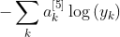
- 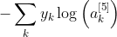
- 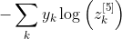
- 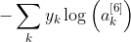
Correct Answer:
- The gradient flowing backward from the output direction through an activation layer with layer index 3 of a deep neural network is
Correct Answer:
- The local gradient of an activation layer with layer index 3 of a deep neural network is
Correct Answer:
- The local gradient of an activation layer (ReLU) with layer index 3 of a deep neural network with 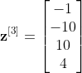 is
- 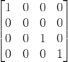
- 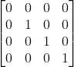
- 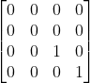
- 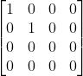
Correct Answer:
- In a 2-layer neural network with 5 neurons in each layer, the shape of the gradient (local weight gradient of dense layer 1) is
- 5 x 6 x 5
- 6 x 5 x 5
- 5 x 5 x 6
- 6 x 6 x 5
Correct Answer:

